

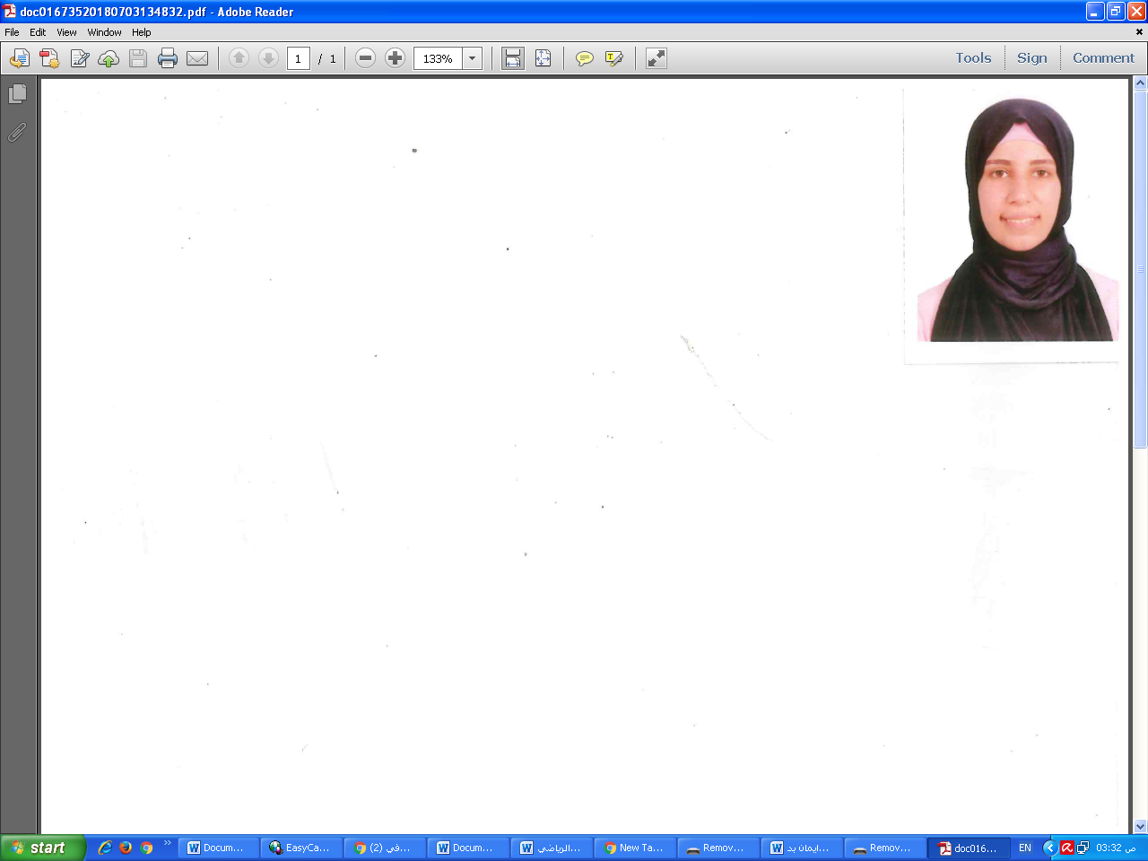**CV**

**Personal Details**

**Name :**Eman Ahmed Ali Badawy

**Address:** Shebin El-kome – menoufia

**E-mail :** [EmanBadawy85@yahoo.com](http://?)

**Cell:**01010715346

**Tel:**0482229893

**Nationality:** Egyptian

**Date of Birth :** 1 January ,1995

**Place of Birth :** Shebin El-koom – Menoufia

**Work Experience:**

Menoufia University, college of Arts, Egypt

Department of English language and linguistics

Demonstrator

* Teaching stylistics, applied linguistics, and other linguistics disciplines

**Education:**

B.A in English language and literature **2017** Menoufia University, Egypt

Very good rating with first honor rank

**Courses Taught**

applied linguistics, and writing and reading

**Training courses:**

English conversation at American University in Cairo (AUC)

**Qualification:**

Tofel certificate (527)

**Languages:**

* English (fluent)
* Arabic ( Native )
* German
* French

**Personal skills:**

* Ability of delivering information by the easiest way
* Ability of managing the class well.
* Seeking for Appling new creative methods of teaching English
* Flexible
* passion for work
* Stamina, hard working.
* Work under pressure.
* Optimistic and co-operator
* Confident, ambitious, sincere and sociable
* Respect for appointments

**Computer Skills:**

Word, power point, windows and office Application

**Interests:**

English and Arabic Literature, Teaching methods, Psychology, philosophy, History and learning new languages.

**Hobbies:**

Reading, Writing short novels, making small accessories .

**References:**

1. Dr. Ahmad Abdel Tawwab Abdel Salam Sharaf Eldin

Assistant professor at college of arts, menoufia university

Cell : 01069403477

E-mail : [Brave107@yahoo.com](http://?)

Website: [http://dr-ahmad.net](http://?)

1. Dr. boshra Elghazoly

Assistant professor at college of arts, menoufia university

Cell : 0101275570

E-mail : [boshra.elghazoly@Gmail.com](http://?)

1. Dr. Nermin Ibrahim

Assistant professor at college of arts, menoufia university

Cell : 01006759667

E-mail : NerminIbrahim79@Gmail.com