كلية: الاقتصاد المنزلي
القسم العلمي: شعبة ملابس – ترم ثاني
الفرقة: الثالثة
اسم المقرر: اللغة الإنجليزية
أستاذ المادة: د. إيمان سعيد محمود عمر
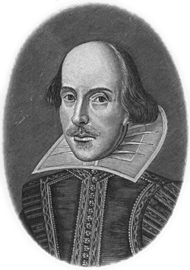

I. The First Question (Writing)

Write a paragraph on (one) of the following topics:
- Social psychology.
- The history of geography.

II. The second Question (Grammar)
Do as shown in brackets:

1. is it the last friday before ramadan (Punctuate this sentence).
2. Goods ……… we have already paid …….. have not yet left your warehouse. (Complete with a relative pronoun and a preposition).
3. I (lose) my own umbrella so I borrowed John’s. (Correct the verb)
4. I lent the girls some of my books. (Use a suitable possessive pronoun).
5. I visited my friend. He was absent from school. (Relate with a relative pronoun).
6. Although she was ill, she went to work. (Use “In spite of”)
7. It is our custom to eat lamb at Easter. (Use “ours”).
8. Mary can solve her problems. She is intelligent. (Join by using “who”).
9. Although the traffic was bad, we arrived on time. (Use “Despite”).
10. Peter is going …….. the seaside ….. his firm so he can combine business ….. pleasure. (Supply particles to make a sensible sentence).

III. The Third Question (Comprehension)

Social psychology is the study of the psychological basic of people’s relationships with one another. Social psychologists investigate such processes as communications, cooperation, competition, decision making, leadership, and changes in attitude.
- Define the “Social psychology”.
- What are the processes investigated by social psychologists?
- What are “surveys” sometimes called?
- The verb “investigate” means ………….
- Demonstrate the work of the social psychologists?

IV. The Fourth Question (Translation)

1) Translate into Arabic:

1. A social class is a group of persons in a society that have about the same social standing. Social classes exist because people usually classify one another into more or less distinct groups based on factors as wealth, power, prestige, ancestry, religion, and occupation.
2. Social psychologists investigate such process as communication, cooperation, competition, decision making, leadership, and changes in attitude.

2) Translate into English:

- تشير العولمة إلى كل المستجدات و التطورات التي تسعى إلى دمج شعوب العالم في مجتمع عالمي واحد.
- المهتمون بأمر القراءة و عالم الكتب هذه الأيام يدركون أن استهلاك الكتاب لم يعد يلق إقبالا كبيرا.

Good Luck
English Department

