

**CURRICULUM VITEA**

* **Personal Data**
* **Name :**  Sanaa Moustafa Safan
* **Date & place of birth :** 19/1/1975- Alshhoda - Menoufia
* **Nationality :** Egyptian
* **Marital status:**  Married
* **Religion:** Moslem
* **Mob:**  01125740474
* **Tel:**
* **E mail:** sanaa_safan@yahoo.com
* **Permanent Address :**  Menoufia University, Faculty of Nursing-
* **Educational Qualifications:**

|  |  |  |
| --- | --- | --- |
| **Faculty of Nursing [ Date from - Date to ]** | **University** | **Degree (s) obtained** |
| 2021 | Menoufia | professor of nursing administration |
| 2015 | Menoufia | Assistance professor of nursing administration |
| 2008 | Menoufia | Doctorate of Nursing science |
| 2003. | Menoufia | Master of Nursing Administration |
| 1996. | Menoufia | Bachelor of General Nursing |

* **Language skills: Indicate competence on a scale of 1 to 5**

(1 Excellent; 5 Basic).

|  |  |  |  |
| --- | --- | --- | --- |
| **Language** | **Reading** | **Speaking** | **Writing** |
| English | 2 | 2 | 2 |
| Arabic | 1 | 1 | 1 |

* **Academic Position and Professional Experience:**

|  |  |  |
| --- | --- | --- |
| **Faculty of Nursing [ Date from - Date to ]** | **Department** | **Academic Position** |
| 1997-2003 | Nursing administration department | Demonstrator |
| 2003-2008 | Nursing administration department | Assistant Lecture |
| 2008**-2015** | Nursing administration department | Lecturer |
| 2011-2021 | Nursing administration department | Director of public service center)  مدير مركز الخدمه العامه |

**Present Responsibilities:**

* **Teaching for under graduate nursing college**
* Teaching nursing administration (2hours) for 3rd years.
* Teaching hospital and health services management (3 hours) for the fourth year in exchange with faculty members from 2015 to 2019.
* Teaching nursing administration (2 hours) for the third year in exchange with faculty members from 2016 /2017- 2017/2018 .
* Teaching scientific research of the fourth year (2 hours) - for the academic year 2010 - 2011 - 2016-2017
* Teaching quality in nursing (2 hours) for the first year in exchange with faculty members for the second semester of the academic year 2013-2014
* **Teachings for Technical institute of nursing**
* Nursing Management and Leadership for For the academic years 2010/2011/2011/2012/2012/2013 / 2013-2014 --- 2016/2017- 2017/2018
* Teaching of Nursing Ethics for technical institute for second year students2010, 2011
* Teaching of Methods or right writing for technical institute for second year students2012/2013
* **Teaching for post graduate ( Master degree)**
* Applied Nursing Research , academic year 2020-2021
* Applied Nursing Research(3 hours) ,Second Semester, the academic year 2017-2018
* Human Resources Management (3 hours) ,The fourth semester of the academic year 2016-2017
* Communications skills, academic year 2015-2016
* Applied Research , academic year 2015-2016
* Critical analysis of research in nursing (3 hours) for the third semester of the academic year 2016-2017
* Communication Skills (2 hours), Third Semester ,the academic year 2015-2016
* Records and Statistics (1 hour) third semester of the academic year 2010-2011
* Nursing Services Development (2 hours) Third Semester for the academic year 2010-2011
* Nursing Management (3 hours) for the second semester of the academic year 2011-2012
* Critical Analysis of Research in Nursing - Third Semester for the academic year 2011 -2012
* Nursing Services Development (3 hours) for the fourth semester of the academic year 2012-2013
* Quality in nursing (3 hours) for the fourth semester of the academic year 2012-2013.
* Nursing Management (2 hours) Third Semester for the academic year 2012-2013
* Quality Assurance in Nursing (2 hours) for the fourth semester of the academic year 2013-2014.
* -Methods of scientific research in nursing (3 hours) First semester for the academic year 2013-2014.
* Methods of scientific research (3 hours) for the second semester of the academic year 2014-2015.
* Theory of organization (1 hour) for the second semester of the academic year 2014-2015
* **Teaching for post graduate ( Doctoral degree)**
* Quality management ,Third Semester,2020-2021
* Research critique (3hours),second semester2019/2020
* Human Resources Management (1 hours) ,The fourth semester of the academic year 2018-2019
* Evidence-based practice(3 hours), Third Semester, the academic year 2018-2019
* scientific research applications in nursing (3 hours) for the first semester of the academic year 2017-2018
* Managing educational institutions (3 hours) for the first semester of the academic year 2017-2018
* Applied research, Second Semester, the academic year 2017-2018
* New Trends ,Second Semester , the academic year 2017-2018
* Seminar in the research dissertation ,Second Semester, Doctoral degree, the academic year 2016-2017
* New Trends ,Second Semester, Doctoral degree, the academic year 2016-2017
* Quality Management in Nursing (3 hours) for the first semester of the academic year 2016-2017
* Teaching methods (3 hours) for the first semester of the academic year 2010-2011
* Methods of scientific research (3 hours) for the first semester of the academic year 2010-2011.
* Strategy for the development of training programs in nursing (3 hours) for the third semester of the academic year 2010-2011.
* Management of schools (3 hours) for the first and second semester of the academic year 2011-2012.
* Teaching methods (3 hours) for the second semester of the academic year 2011-2012.
* Seminar material in the subject of the thesis (3 hours) the first semester of the academic year 011-2-2012
* Seminar material on the subject of study (3 hours) for the first semester of the academic year 2012-2013
* Critical analysis of research in nursing (3 hours) for the third semester of the academic year 2012-2013
* Human Resources Management (3 hours) for the first semester of the academic year 2012-2013.
* Nursing Management (3 hours) for the second semester of the academic year 2013-2014
* Human Resources Management (3 hours) for the third semester of the academic year 2013-2014
* Quality in nursing (3 hours) for the second semester of the academic year 2013-2014
* -Nursing Management (3 hours) for the third semester of the academic year 2014-2015
* **Social and cultural activities:**

1-Member of Internship committee (2010/2011)

2-Member of environment committee (2011/2012)

3-Member Member of post graduate committee (2012/2013)

4-Supervision of Nurse Interns (2008-2013)

* **Supervising the following thesis:**

**Supervising of doctoral thesis**

1. Designing self-Learning Package :A mean for Prevention of Occupational Hazard that Face Nursing Staff
2. Developing and implementing an innovative managerial skills training program for nurse managers
3. Training program of total quality management for unit nurse managers
4. Work design and its relationship to nurses' involvement in decision making and their productivity
5. Staff Performance Appraisal System and its Relation to Their Job Satisfaction and Empowerment: Developing Performance Appraisal Tool .

* **Master thesis**

1. Role of the emotional intelligence in conflict management strategies among nurse manager**.**
2. Nurse's perception toward talent management and its relationship to their work engagement and retention
3. Relationship between Motivating Work Factors and Nurses’ Retention in selected Hospitals at Shebin –Elkom
4. Study of nursing intern's needs through their practical competency self- evaluation.
5. Perception of Electronic Learning among nursing students and teaching Staff and its Relation to their Satisfaction .
6. Collaboration among nurses and its relation to their professionalism**(** Menoufia university **).**
7. Clinical Rotation And Role Vagueness among Nurse Interns and Its Effect on Their Self Confidence
8. Perception toward priority setting and locus of control among bachelor nursing graduate
9. Relationship between first line manager authority and staff nurses’ participation in decision making.
10. Nurses Perception Toward Quality Of Nursing Care Obstacles and Its Effect on Their Performance
11. Nurses Application of International Patient Safety Goals at Accredited and Non-Accredited Hospital.

* **Discussion Statement of Scientific Dissertations**:

1. -"Develop an effective preventive program for workplace violence for nursing personnel as a means of allocating Shift from nursing work "(ph.d)
2. Head Nurses Perception toward their managerial skills and its relation to their patient advocacy at Benha University Hospital(Msc.).
3. The Relationship between Nursing Night Shift problems and quality of patient s care at Benha University Hospital (Msc.).
4. -The Relationship between Nursing Night Shift problems and quality of patients s care at Benha University Hospital (Msc.).
5. Nurse's compliance with medication safety measure and it is relation to quality of nursing care (Msc.).

* **Scientific Conferences:**
* Attending the Second International Student Conference of the Faculty of Nursing - Menoufia University entitled "Sustainability and creativity among nursing students to achieve vision" 2030 on 2/26/2020
* Member of the communication committee at the Sixth International Scientific Conference at the Faculty of Nursing - Menoufia University on 1-2 October 2019 under the title: "Sustainable Development of Nursing, Education and Research"
* Attendance and participation in a poster (a working paper) entitled “Managerial Competencies” in the Sixth and Third International Scientific Conference at the Faculty of Nursing, Benha University, on 7/31/2019 entitled: “International Standards and Competences: Nursing Voice”
* • Participating in a paper presentation entitled "Role of the emotional intelligence in conflict management strategies among nurse manager" at the Sixth International Scientific Conference at the Faculty of Nursing - Menoufia University on 1-2 October 2019 under the title: "Sustainable Development of Nursing, Education and Research
* Attendance in the 14th international congress toward "Eminence in Nursing: Education, Research, and Management" from 9th- 10th

at Ain Shams University .

* Attending and participating in giving a paper (Paper Presentation) on 7/31/2019 entitled "Perception toward priority setting and locus of control among bachelor nursing graduate" at the sixth and third international scientific conference, Faculty of Nursing, Benha University, entitled: Nursing Voice: International Standards and Competences
* Attendance and participation in the third international scientific conference at the Faculty of Nursing - Helwan University in cooperation with the Faculty of Nursing, University of Knyson, USA, entitled "Modern technologies and specializations in nursing education" on 18-19 May 2011 Poster tilled "the role of best practice and innovation in organizational effectiveness"
* Attendance and participation in the presentation of the Fourth International Conference at the Faculty of Nursing - Helwan University in cooperation with the Faculty of Nursing, University of Knyson, USA, "Innovations in Nursing Research, Education and Practice" on 23-24 April 2012 .The title of the research is "The administrative tasks performed by different administrative nursing levels and their awareness"
* Attendance and participation in the Third International Scientific Conference Faculty of Nursing Monofiya University "Towards excellence in the nursing profession" from 27-28 February 2011
* Attendance and participation in the fifth conference of the Faculty of Nursing Zagazig University "Nursing between reality and ambition" 27 April 2009 and submission:
  + Poster tilled: "Effective Team Building"
* Attendance and participation in the eighth annual scientific conference of the Faculty of Nursing Zagazig University "Challenges of nursing in rehabilitation and professionalism" on 10 November 2014
  + Poster tilled: Nursing Technology Informatic
* -Attendance at the Fourth International Scientific Conference of the Faculty of Nursing - Menoufia University "Use of Scientific Research in Nursing" on 9-10 May 2014
* -Attendance at the Second International Scientific Conference of the Faculty of Nursing - Menoufia University "Quality of nursing performance between challenges and ambition" on 24 - 25 February 2010
* -Attendance at the 22nd International Scientific Conference of the Faculty of Medicine, Menoufia University "New Horizons after Accreditation" on 28 April - 1 May 2011

"

* **Workshops and training courses**    **\*\* workshops** :
* Attending an online workshop entitled “Technological Innovation and Digital Transformation” for a daily period on 7/28/2020 through the zoom metting program by the Ministry of Communication and Information Technology for Institutional Development
* Active participation in the activities of the field workshop at the Faculty of Nursing, Menoufia University, by the Federation of Arab Universities, the Arab Council for Quality Assurance and Accreditation, and the Scientific Society of Arab Nursing Faculties.ϖ
* Attending the workshop entitled “Rules and System of Work of the Scientific Committee for the Nursing Sector, Third Session” held at the Faculty of Nursing - Menoufia University on 12/8/2019ϖ
* Attending the workshop entitled "How to develop exams and how to put questions" held at the Department of Nursing Administration, Faculty of Nursing - Menoufia University on 11/11/2019
* Attending the workshop entitled "Blue Print Exam Application" held at the Faculty of Nursing - Menoufia University on 02/24/2019
* Attending the workshop entitled “Exam Paper Specifications Consistent with Quality and Accreditation Requirements” held at the Faculty of Nursing - Menoufia University on 18-19 / 4/2018ϖ
* Attending a workshop on "introducing the vision, mission, strategic objectives and values ​​governing the college"Faculty of Nursing, Menoufia University, by the strategic planning standard working group on 7/8/2018
* Attending the workshop entitled "power analysis and sample size calculations" at the third annual scientific conference of the Department of Community Health Nursing at the College of Nursing - Menoufia University on 1/12/2017
* Attending the workshop entitled "New Standards and Accreditation Indicators According to the Accreditation Guide for Faculties and Institutes of Higher Education" held at the Faculty of Nursing - Menoufia University on 10/26/2016
* Attend a seminar entitled "Job description of the various nursing leaders in the Faculty of Nursing 2011.
* Holding a seminar for students of excellence entitled "Common mistakes in critical units" in the scientific section of the college 9/2/2012.
* Attend a seminar for students of excellence entitled "How to write a biography" in the scientific section of the college for the academic year 2013-2014.
* Attend a seminar on how to work the environmental analysis of the Faculty of Faculty of Nursing / University of Menoufia
* Attend a seminar on promotion rules on 30 March 2015
* **\*\* training courses :**
* participation as a trainer for giving a lecture entitled “Principles of the training process and influencing elements in the training process” as well as a lecture entitled “The difference between education and training, methods of training and training aids” on November 27, 2018 in the Directorate of Health Affairs in Menoufia Governorate
* participation as a trainer in the training session held in the field of "development of management skills" in the training hall of the Director of Health Affairs in Menoufia Governorate by giving lectures entitled "The basic principles of successful management - components of the administrative process - planning" as well as by giving a lecture entitled "Method of Analysis of Strengths Weakness, Opportunities and Threats "on 3/27/2017♣
* Attending a training course entitled "Self-Assessment for Colleges and Institutes of Higher Education" from The National Authority for Quality Assurance and Accreditation in the period from 3/13 to 3/15/2018
* Attending a training course entitled "Strategic Planning for Colleges and Institutes of Higher Education" From the National Authority for Quality Assurance and Accreditation in the period from 5 / 8-8 / 6/8/2018
* Attending the training course on (Egyptian Knowledge Bank services) on 17th, 18/11/2018 at the Digital Library headquarters at the General Administration of Menoufia University.
* Participation in the activities of the workshop entitled "How to prepare and formulate the tools of scientific research - questionnaire and observation" Faculty of Nursing - University of Banha 28 - 11 2012
* Attended a workshop on "Leadership Skills" at the Suzanne Mubarak Regional Center for Maternal Health and Women's Development on 19 April 9,2012
* -. Attendance and participation in a workshop at the Faculty of Nursing, Department of Nursing Management, Alexandria University, 12 May 2008, entitled "Nurse Manager: Opportunities and challenges"
* Participation in the activities of the workshop entitled "strategies of management of shortage in nursing" 4/2/2013 Faculty of Nursing - University of Menoufia.
* Lecture entitled "Disposal of waste and health facilities" in the course of infection control at the Public Service Center Faculty of Nursing - University of Menoufia 30 - 1 - 2013.
* Participated in the implementation of the training course in the field of "Development of managerial skills" from 15-12-2012 until 18-12-2012 at the training center of the Directorate of Health in Monofiya governorate, delivered a lecture entitled "The basic concepts and principles of management"
* How to write a course description and a course report for the bachelor's, master's and doctoral degrees.

- Attend the course for the development of faculty members entitled "Examination Systems" and the evaluation of students "in the period from 17/5/2015 to 18/5/2015 at the University of Menoufia.

- Attending the Training course titled "Strategic Planning"

In the period from 29/3/2009 to 31/3/2009 at the University of Menoufia.

- Attending Training course entitled "University and Society"

In the period from 14/4/2015 to 15/4/2015 at the University of Menoufia.

- Attend the Training course entitled "management of people"

 In the period from 5/5/2015 to 6/5/2015 at the University of Menoufia

- Attending Training course faculty development course titled "Ethics of Scientific Research"

 In the period from 6/1/2015 to 7/1/2015 at the University of Menoufia.

-Attendance Training course entitled "Quality standards in the teaching process" from 21/4/2015 to 22/4/2015 at Menoufia University

**Projects:**

-Participating in implementation Accreditation Program. In the Faculty of Nursing. Menoufia University, since 2010- 2014 and after accreditation until now( 2019)

-Participate in CIQAP project starting from September 2009 to 2011 at the College.

- Participating in the project of establishing an internal quality and accreditation project (QAAP) at the college.

* **Publications:**
* 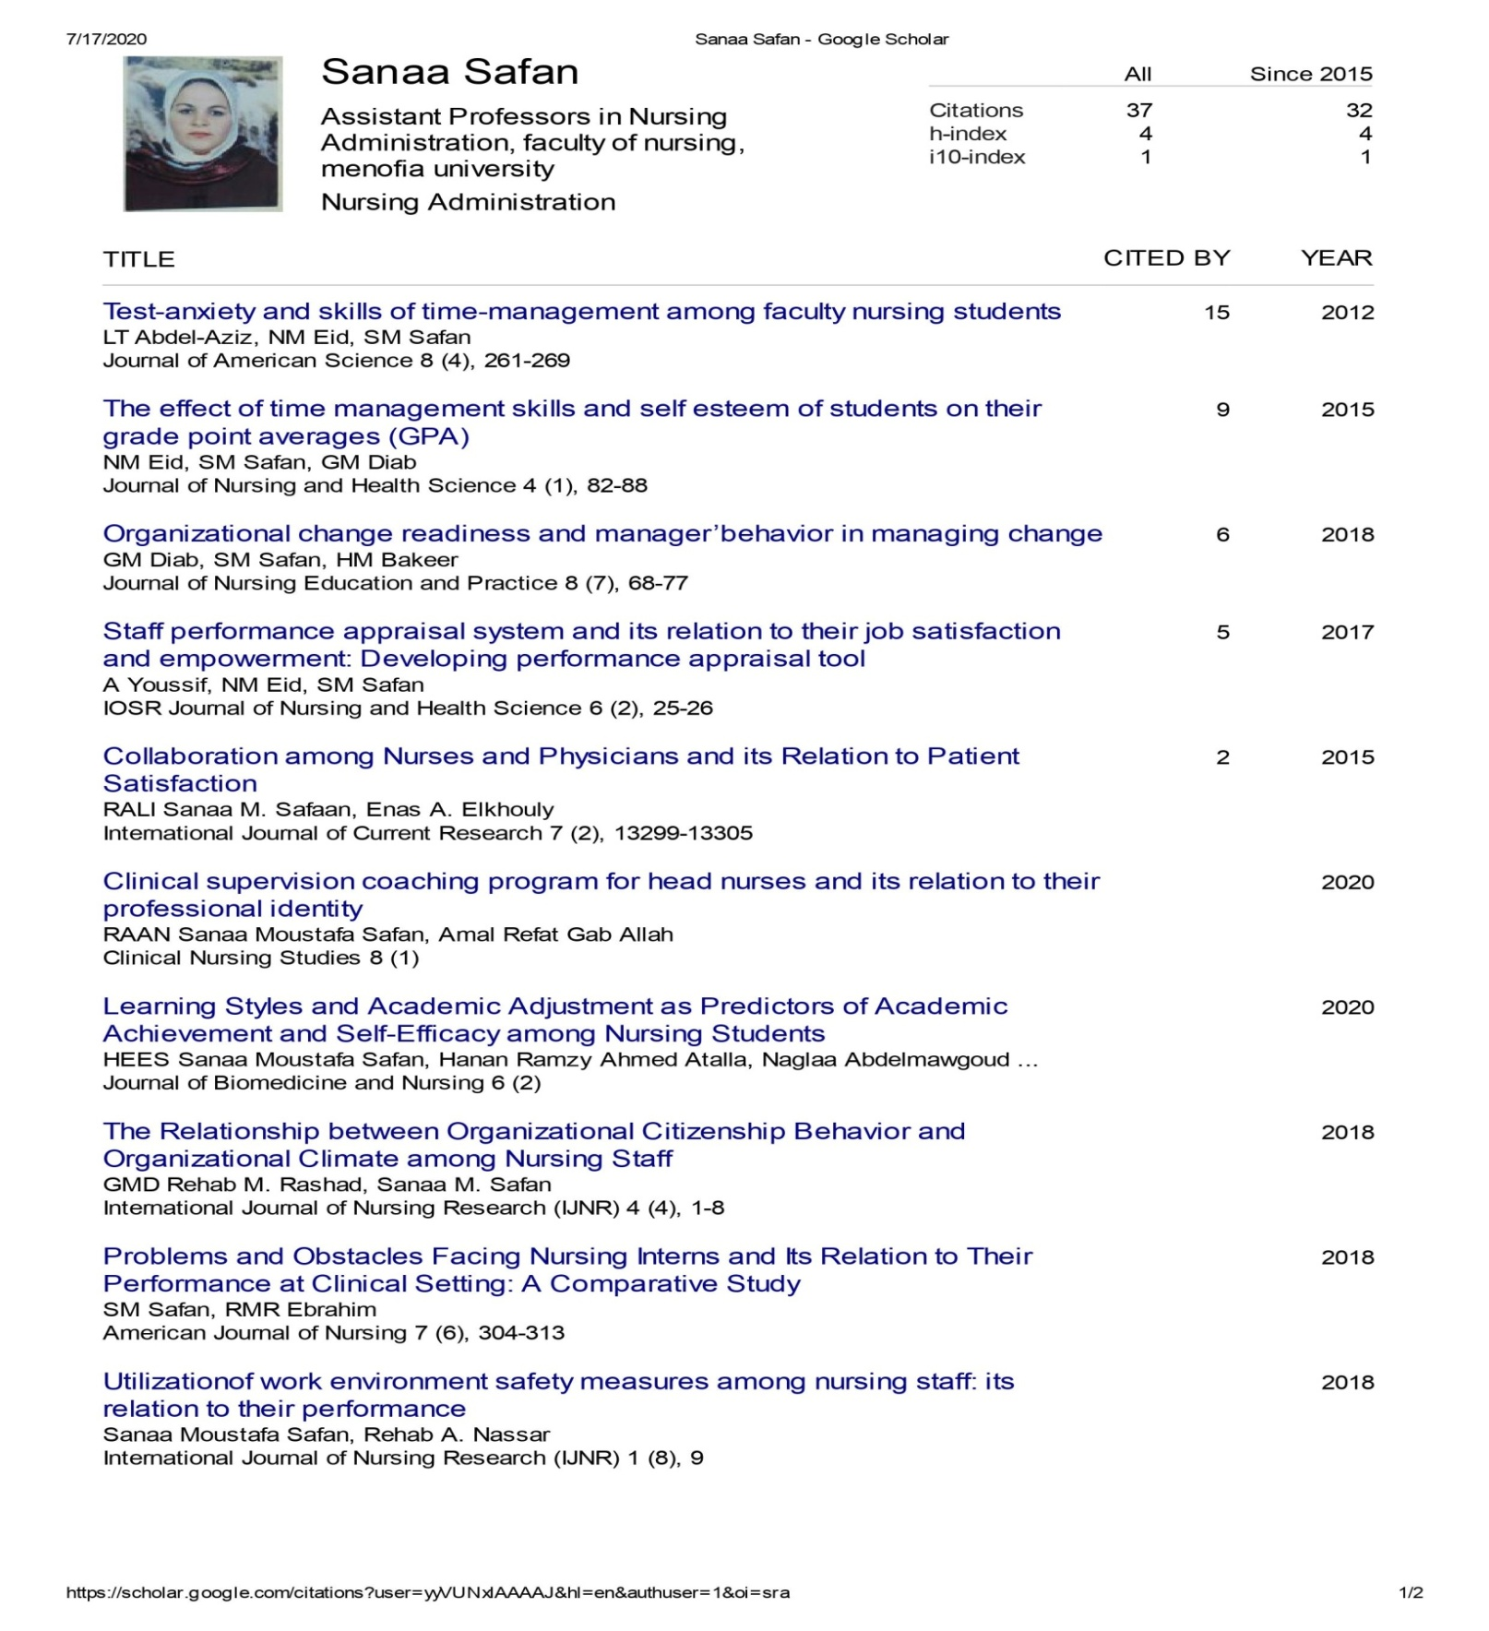

|  |
| --- |
| 1. **Staff Performance Appraisal System and its Relation to Their Job satisfaction and Empowerment: Developing Performance Appraisal Tool.** IOSR Journal of Nursing and Health Science (IOSR-JNHS)2017;Volume 6, Issue 2 , PP 17-27 2. **Problems and obstacles facing nursing interns and its relation to their performance at clinical setting: a comparative study.** American Journal of Nursing Science. December 19, 2018; Vol. 7,No.6 pp. 304-313 3. **The Relationship between Organizational Citizenship Behavior and Organizational Climate among Nursing Staff.** International Journal of Nursing Research (IJNR). ( Oct-Dec)2018; Vol. 4, No.4. pp1-8. 4. **Implementing structured model of clinical handover(SHARED): Its influence on nurses’ satisfaction** ,Clinical Nursing Studies ,March 2019; Vol. 7, No. 1, pp.71-82 5. [**Total Quality Management Practices from Unit Nurse Managers’ Perspectives**](http://?)   JOJ Nursing & Health Care (JOJNHC) ,2018, Vol. 9,No (1)   1. **.Nursing Professionalism: A Concept Analysis Menoufia Nursing Journal**   Menoufia Nursing Journal , November / 2018. Vol 3 . No. 2   1. **Relationship between Motivating Work Factors and Nurses’ Retention in selected Hospitals at Shebin –Elkom /**   Menoufia  **Scientific** Nursing Journa November / 2016. Vol 1. No. 2 l  **8.Perception toward priority setting and locus of control among bachelor nursing graduate.**  المؤتمر العلمى السادس والدولى الثالث كلية التمريض جامعة بنها بالتعاون مع جامعة بوب جونز فى جرينفيل جنوب كارولينا بالولايات المتحدة الأمريكية وجامعة لينكولن بماليزيا وجامعة نجران بالمملكة العربية السعودية وكليات الغد الدولية للعلوم الطبية التطبيقية بتاريخ 13/7/2019 |

* Others **Publications:**