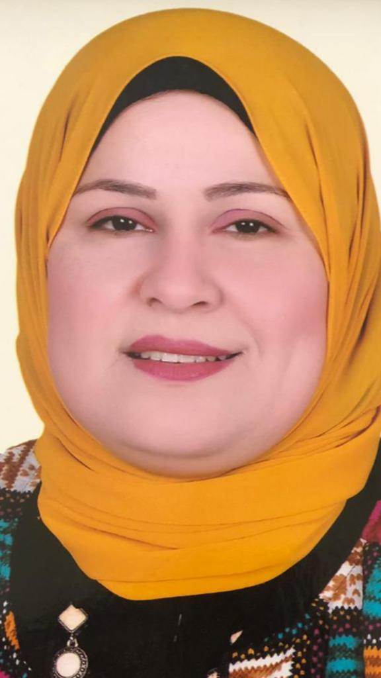

C.V.

Name : Hoda Soliman Mohammed Soliman.

Address : 14 Mohammed Hassanin Haikel St., Al- Mandara – Al- Montaza , Alexandria , Egypt.

Work Address : Department of English, Faculty of Arts, Shebin El- Kom, Minufiya University, Egypt.

Phone Number : Home (048)2194679-(048)3663844.(03)55533382
Mobile (002)01066542946- 01008604147

Office (048)2221987

Date Of Birth : August 12, 1974.

Place of Birth : Menouf, Minufiya, Egypt.

E-mail : dr.hodas@yahoo.com

POSITION :
- Head of Department of English, Faculty of Arts, Minufiya University, December 2018, till the present time.
- Associate Professor of English Literature , Department of English Language & Literature, Faculty of Arts, Minufiya University, Egypt.From October 2017 till the present time.
- Lecturer in English Literature , Department of English Language & Literature, Faculty of Arts, Minufiya University, Egypt.From 2010 to 2017
- Co-ordinator of the seminar of the Department of English Language & Literature, Faculty of Arts, Minufiya University, Egypt.2009-2010
- Assistant Professor in English Literature, at Department of English, Faculty of Arts, Al- Baha University( K.S.A) .From 2010- 2013
- Co-ordinator of the cultural committee, Faculty of Arts, Al- Baha University(K.S.A) (1431-1432 H).
- Head of committees of activity, Faculty of Arts, Al- Baha University(K.S.A) (1432-1433 H) (1433-1434).
- A member of committee of supervising the liberary , Faculty of Arts, Minufiya University, 2014-2015.
- Head of Quality assurance, Faculty of Arts, Minufiya University, 2017-2018.

qualifications :
- B.A. in English and Education, Faculty of Education, Minufiya University, Egypt, May, 1996. Very Good Grade (Hons)
- Diploma in Education, Faculty of Education, Minufiya University. 2001 (Excellent Grade)
- B.A. in English, Faculty of Arts, Minufiya University, Egypt, May,2001.(Very Good Grade)
- Pre-luminary in English Literature,Faculty of Arts, Cairo University,2002.
- Master Degree in English Literature, Department of English, Faculty of Arts, Minufiya University,2005. (Excellent Grade). Under The Tittle ( A Hermeneutic Study of the Dramatic Dialogue Between the Self and the Other in Harold Pinter's Old Times and No Man's Land ).
- Ph.D. in Comparative Literature, English Department, Faculty of Arts, Banha University,2010. (First Class Honors).Under The Tittle (The Impact of Western Drama upon Yusuf Idris' plays).

EXTRA QUALIFICATIONS :
- Attended a course in Learning Computer at The Centre of Information and Technology, Minufiya University (The use of Digital Library and Database) Excellent Grade.2009.
- Attended six courses in Faculty and Leadership Development Project, Minufiya University, from Nov. 2007 to Dec.2008.
- Attended a 60 Hours Course in Local TOEFL from 5-4-2009 to 26-4- 2009 at Community Service Sector, Banha University, with 642 score records out of 650.
- Attended three levels of a computer course: Windows, Word, and Excel, Banha University, from 10-2-2009 to 28-2-2009.
- Attended a course in electronic language labs, Faculty of Arts, Al- Baha University(K.S.A) (1431 H).
- Attended six courses in Faculty and Leadership Development Project, Minufiya University, From Jan.to March 2017.
- Attended An International Conference at Facultyof Arts , Minufiya University, on December 2017.

TEACHING EXPERIENCE:
- A Demonstrator at Department of English, Faculty of Arts, Minufiya University from 2002 :2005.
- Assistant Lecturer in English Literature, at Department of English, Faculty of Arts, Minufiya University from 2005 :2010.
- Lecturer in English Literature, at Department of English, Faculty of Arts, Minufiya University from May 2010 till the present time.
- Assistant Professor of English and Literature, Faculty of Arts, Al-Baha University for years (1431-1432 H) (1432-1433 H)&(1433-1434 H).
EXPERIENCE : Taught and still teaching at Department of English, Faculty of Arts, Minufiya University, Egypt from 2001 to 2010 . Courses include: English Drama, English Novel, Poetry , Modern Criticism, Modern Novel, American Drama, and American Fiction.
Taught and still teaching at Department of English, Faculty of Arts, Al-Baha University, K.S.A. from 2010 to the present time. Courses include: English Drama, Poetry , and Introduction to Literature.
Taught at Department of English, Faculty of Education, Al-Baha University, K.S.A. Second Semester 2011.Courses include: English Drama, American Drama, English Novel, and American Novel.
Taught EFL/ESL-Faculty of Education, Department of Educational Leadership, M.A. Students, Level 1, Al-Baha University, K.S.A. 2011, First Semester.
Taught EFL/ESL-Faculty of Science, Department of Math, and Computers , M.A. Program , Level 1, Al-Baha University, K.S.A. 2012, Second Semester.
Taught a course in psycholinguistics -Faculty of Arts and Humanities , Department of English , M.A. Program in Applied Linguistics , Al-Baha University, K.S.A. 2012, Second Semester.
Taught an Intensive course in Grammar -Faculty of Arts and Humanities , Department of English , M.A. Program , Al-Baha University, K.S.A. 2012, Second Semester.
Taught EFL/ESL-Faculty of Education, Department of Orientation and Counselling, M.A. Students, Level 1, Al-Baha University, K.S.A. 2012, First Semester.
Taught courses in Introduction to drama, Shakespeare and drama 1, Shakespeare and drama2 , and Comparative literature for undergraduates -Faculty of Arts , Department of English Minufiya University, 2014- till the present time.
Taught courses in Introduction to drama, Shakespeare and drama 1, Shakespeare and drama2 , Introduction to Literary Criticism, Criticism 1, Criticism 2, Criticim3, Writing 4, Modern drama, and Discourse Analysis for undergraduates -Faculty of Education , Minufiya University, 2014- till the present time..
Taught a course in Bibliography-Faculty of Arts , Department of English , M.A. Program in Linguistics , Minufiya University, 2014-2015.
Taught courses in Bibliography, English Drama, Litrary Theory, and Comparative Literature -Faculty of Arts , Department of English , M.A. Program in Literature , Minufiya University, 2015-2016.,2016-2017- 2017-2018&2018-2019.
Taught EFL/ESL-Faculty of Agriculture, , M.A. and PhD Students, Minufiya University, 2014-2015, 2015-2016, 2016-2017 .
Taught EFL/ESL-Faculty of Agriculture, Program of Open Learning, Minufiya University, 2015-2016, 2016-2017 .
Taught EFL/ESL-Faculty of Tourism and Hotels, Private Program , Sadat University, , 2017-2018.
Taught courses in Comparative Literature , Literary Theory -Faculty of Languages and Translation, , Department of English , M.A. Program in Literature , Minufiya University and 6th October University, 2018-2019.

AREAS OF INTEREST :
- Comparative Literature
- The history of English Drama
- History of Arab and Egyptian Drama
- Modern Criticism
- Orientalism
- Theatre and Performance
- Egyptian folkloric traditional dramatic form
- American Literature
- EFL/ESL
- History of English Literature
- Introduction to Criticism

Published Research Papers:

1-On Translating a Shakespearean Soliloquy into Arabic
ترجمة المناجاة عند شكسبير الى اللغة العربية

Ain Shams University. Fakr Wa Ebdaa, 2016

2-Mahfuz Abdelrahman’s Adaptation of An Inspector Calls by J.B. Priestley: An Exercise in Transposition
اقتباس محفوظ عبد الرحمن لمسرحية برستلى" زيارة مفتش":
نحو محاولة لملاءمة الادوار
Herms, Faculty of Arts, Ciro University, 2016.

3-Shakespeare's Merry Wives of Windsor in an Egyptian Adaptation:
A Study in Cultural Appropriation

تمصير مسرحية "زوجتان مرحتان من وندسور" لشكسبير :
دراسة فى التطويع الثقافى
(Ells), Faculty of Education, Ain Shams University, 2016.

4-On Drama Translation:Katerina Reiss's Text Types revisited
with Reference to Shakespearean Translation into Arabic
ءاعادة النظر فى أنماط النصوص عند كاترينا رايس
(بالاشارة ءالى ترجمة شكسبير ءالى اللغة العربية)
College of Girls, Ain Shams University. 2017.

5-Tom Stoppard's 'If You're Glad I'll be Frank'As an existential play:
A Heideggerian Approach
مسرحية "الساعة الناطقة" لتوم ستوبارد كمسرحية وجودية: مدخل هايديجيرى

Bulletin of the Faculty of Arts, Cairo University, 2017.

Supervision:
1-M.A. thesis:
Translating Collocations from Arabic into English in Selected Novels by Naguib Mahfouz: A Semantic Analysis. .2016
Submitted by Nabila El-Sayed Harhash
Submitted to Department of English, Faculty of Arts, Minufiya University.

2-M.A.thesis:
Code- Switching between Arabic and English in Selected Egyptian Talk Shows: A Sociolinguistic Study, 2016.
Submitted by Menna Allah Fathi Abdelfatah Aboelnabial.
Submitted to Department of English, Faculty of Arts, Minufiya University.

3-M.A. thesis:
Racism in Selected plays by Lorraine Hansberry, August Wilson, and Bruce Norris. A Post Cultural / Post Racial Approach. 2017
Submitted by Lara Hany Edward Farid
Submitted to Department of English, Faculty of Arts, Minufiya University.

4-M.A. thesis:
Gender Differences in Southern American Drama as Reflected in selected plays by Lillian Hellman and Beth Henley. A socio-Feminist Approach.2017
Submitted by Basem Mohammed Sweed
Submitted to Department of English, Faculty of Arts, Minufiya University.

5-M.A. thesis:
Adaptation and Cultural Appropriation in Western and Egyptian Drama: A Comparative Study,2018.
Submitted by Alyaa Abdel Mohsen Kennawi
Submitted to Department of English, Faculty of Arts, Minufiya University.

Viva member:

1-Adaptation and Appropriation: Post- Colonial Returnings of Hamlet in Femi Osofisan's The chattering and the Song (1977), Akbar Radi's Hamlet with Season Salad (1988) and Sulayman Al Bassam's The Al Hamlet Summit (2006) By Rabab Said Sayed Ahmed Gad, A demonstrator at Department of English, Faculty of Arts, Minufiya University. July,2017.

2- Race and Gender in Selected Plays by Adrienne Kennedy and Sonia Sancheiz : A Study in the Development of Black Feminism: M.A. thesis by Doaa Mohammed El-Lehleh, A demonstrator at Department of English, Faculty of Arts, Minufiya University. November,2018.

3- The Poetics of Confession in Selected Poems by Anne Sexton: A Gynocritical Study : M.A. thesis by Sara Osama Madany, A demonstrator at Department of English, Faculty of Arts, Minufiya University. August, 2019.

Reference People to contact
Prof. Mohammed Mohammed Enani.
Professor of English Literature,
Faculty of Arts, Cairo University.
Mobile: 002012444466

